Chaffinch

Dominic Munns

04/11/2020

#Introduction Chaffinches are very abundant in Britain, it’s pattern helps it to blend into the environment when it is feeding on the ground (**???**). The wingspan of a chaffinch is 24.5-28.5cm and the mass is 18-29 grams (**???**). Males (see figure 1) and females (see figure 2) have different appearances.

#(ref:chaffmale-fig) Male Chaffinch on a branch. By Photo © Andreas Trepte, CC BY-SA 2.5, <https://commons.wikimedia.org/w/index.php?curid=3877642>) #(ref:weddell-fig) Baby Weddell Seals are very cute. By Photo © Andreas, CC BY-SA 2.5, <https://commons.wikimedia.org/w/index.php?curid=3877642>

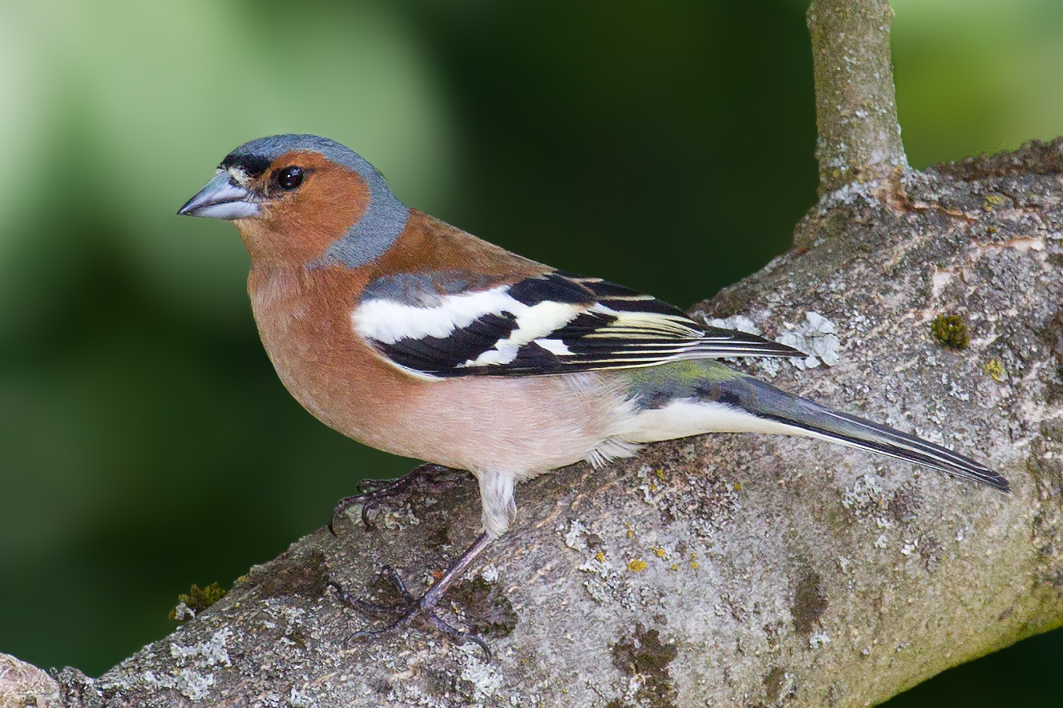

Figure 1: (ref:chaffmale-fig)

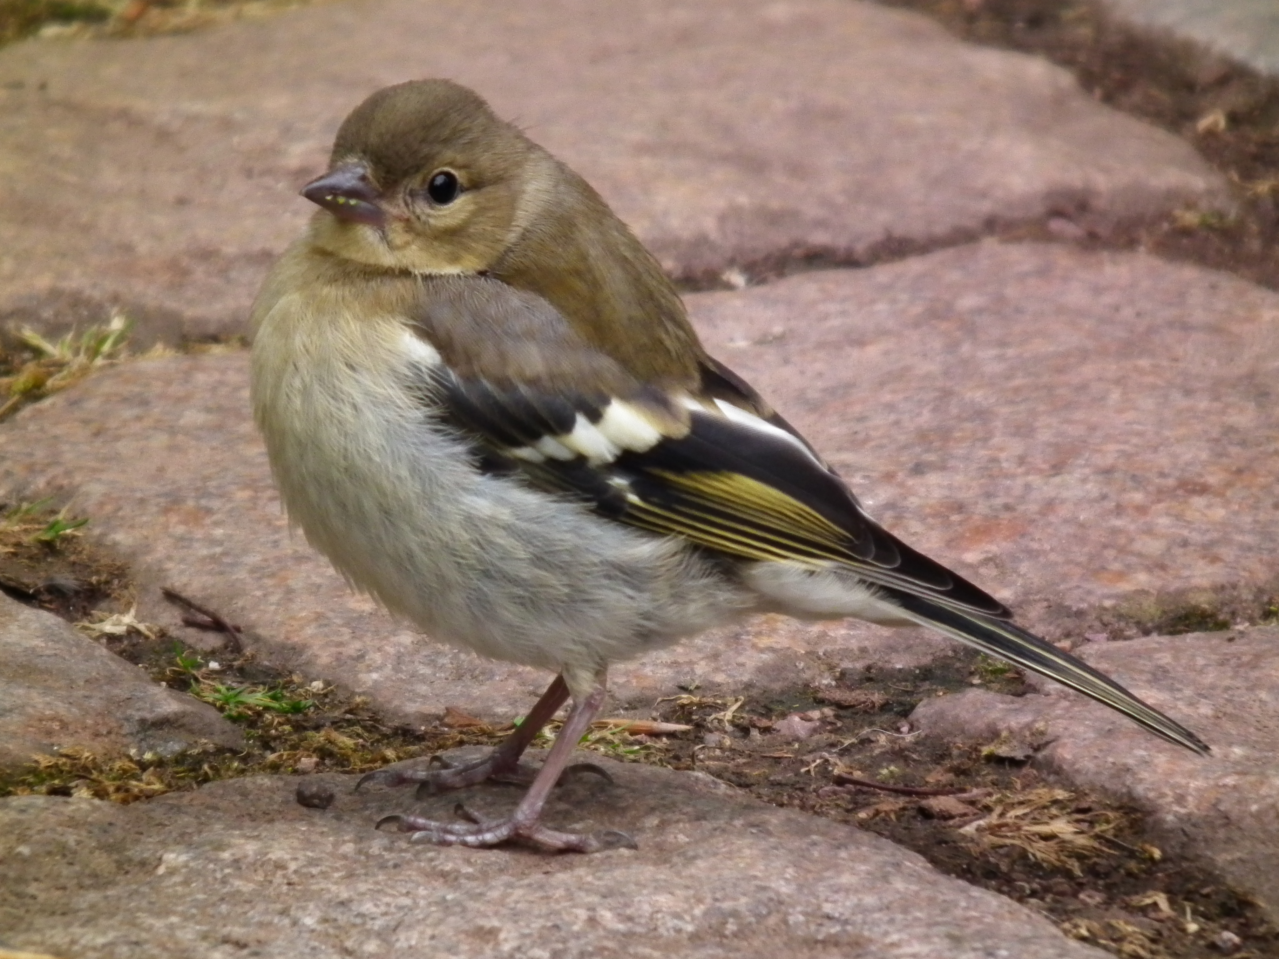

Figure 2: (ref:chafffemale-fig)

#Methods Some interesting techniques.

#Results

#Discussion

#Bibliography

## # A tibble: 2 x 2  
## sex ss  
## <chr> <dbl>  
## 1 females 86.8  
## 2 males 87.9